Effect of LP Model Length on Formant Frequencies
This short report shows the effect of linear prediction model length on the location of extracted formant frequencies. The plots shown in this report were produced using truncated seven sound samples ( with 15% removed on each end). The labels next to the location show the spoken word.
After truncation, the lengths of speech segments were in the range of 8694 – 17150 samples. Hence we have tried LP polynomials in 100 – 150 range. The following figure shows four of the plots. The model lengths in the figure are 120 (top-left), 130 (top-right), 140 (bottom-left) and 150 (bottom-right). We can see that the locations of spoken vowels do change with a change in model length.
One reason for this inconsistency could be the sub-optimal truncation of spoken words. If we hear the speech segments after 15% truncation, we can still hear parts of consonants. We can go ahead with iOS implementation with a model length of 120 and can investigate this problem further at a later time.
A zip file is being sent that includes this report, the MATLAB code, and seven wav files of truncated speech segments.
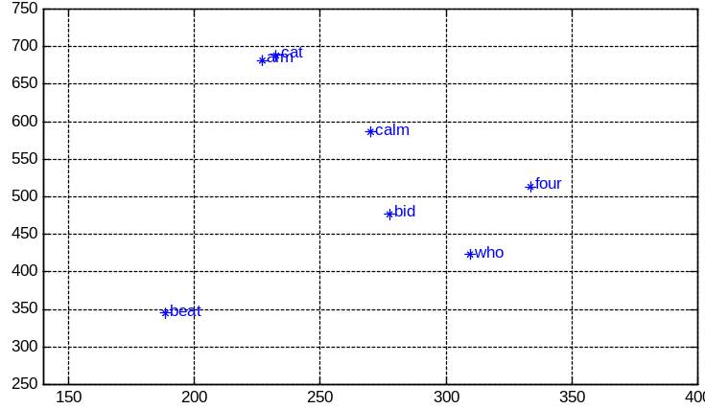 | 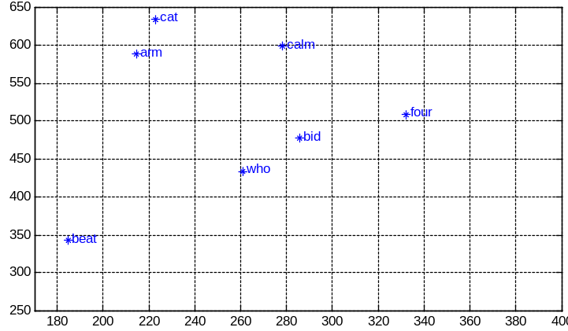
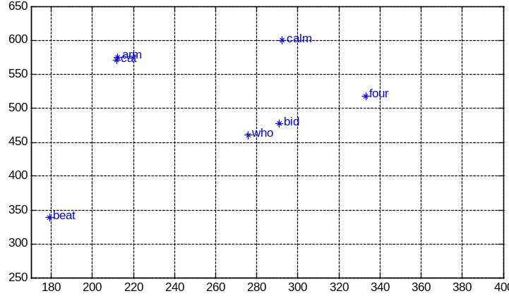 | 